Chapter 5
Individually Randomized Trials with No Clustering

Introduction
The simplest randomized designs are individually randomized trials with no clustering. In such designs it is possible to assign individuals to treatments independently from one another. This design is not possible if (for practical or political reasons) the individuals in the same classroom or school must be assigned to the same treatment. In that case the design would be a cluster randomized design (one where whole statistical clusters such as school or classrooms are assigned to treatment or some variety of randomized block design (where treatment assignment is carried out withing clusters such as schools).

Statistical Model and Notation
Suppose that the design has n individuals that are randomly assigned to each of the treatment and the control condition. Such a design is called a balanced design because there are equal numbers of individuals assigned to each treatment. Balanced designs are desirable because they are the most sensitive, that is they produce statistical tests that have the highest statistical power and the most precise estimate of treatment effects for a given total sample size. Then, in the conventional notation of the analysis of variance, the model for Y_{ij}, the outcome measurement of the j^{h} individual in the i^{th} treatment, is
Y_{ij} = μ + α_{i} + ε_{ij}, i = 1, 2; j = 1, …, n, (1)
where μ is the grand mean, α_{i} is the effect of the i^{th} treatment and ε_{ij} is a residual. The residual ε_{ij} is assumed to have a normal distribution with variance σ_{ε}² and the grand mean μ and the treatment effects α_{i} are taken to be fixed, but unknown constants.
In this design, it is conventional to define the effect size as the standardized mean difference
,
(see, Hedges, 1981).
Let andbe the means of the j^{th} treatment and control groups, respectively, and letbe the grand mean. This notation with dots in the subscripts may seem confusing, but it has a logic. It takes the values of all four subscripts to identify a particular observation, but one could average over all observations in treatment group 1 to obtain (here that average is denoted by dots in the second subscripts which identify the individual within treatment group to denote averaging over individuals and clusters).

The Statistical Analysis of the Design

In the analysis of this design, the overall treatment effect estimate is
.
The test statistic used for testing treatment effects is
F = MST/MSCT,
where MST is the so-called treatment mean square defined by
,
and MSW is the so-called within-treatment-groups mean square defined by
(see, e.g., Kirk, 1995). When the null hypothesis of no treatment effects is true, the test statistic has the F-distribution with 1 degree of freedom in the numerator and 2(n – 1) degrees of freedom in the denominator. Thus we carry out the significance test by comparing the obtained value of F with the appropriate critical value of the F-distribution with 1 and 2(n – 1) degrees of freedom or by using the p-value computed by the analysis software.
The standard error (precision) of the treatment effect estimate is
.

Planning Individually Randomized Designs

The object planning a research design is to ensure that if the data is collected according to the design, the analysis of that data will yield unambiguous results. To ensure results will be unambiguous, the design has to be sufficiently sensitive. There are three different, but complementary, ways to describe design sensitivity, all of which can be useful in planning designs.
One way to describe design sensitivity is statistical power. Statistical power is the chance that if there is a (true or underlying) intervention effect of a given size, the statistical analysis is likely to detect it. Statistical power analysis starts with the size of an effect that is deemed important enough to detect, and a design (e.g., a sample size configuration), and describes the probability that an effect of the given size would result in a statistically significant observed effect. Computation of statistical power can be accomplished by suing tables of power values, but is more easily accomplished using specialized software
Another way to describe design sensitivity is the use of minimal detectable effect size. The minimal detectable effect size is the smallest effect size for which the design has a given statistical power. Using this approach, one starts with design (a sample size configuration) and a desired level of statistical power and describes the smallest effect size for which the design has the specified level of statistical power. Approximate computations of minimum detectable effect size can be done using tables, but exact computations of require specialized software.
A third way to describe design sensitivity is precision. Precision is the standard error of the estimated treatment effect, which determines the width of the confidence interval for the treatment effect. Using precision analysis, one starts with the design (a sample size configuration) and computes the precision that would be expected.

General Principles for Planning Individually Randomized Designs
Planning an individually randomized design to evaluate an educational intervention primarily involves choosing a design that will have adequate sensitivity (high statistical power and precision, or small minimal detectable effect size). In principle, design sensitivity depends on the significance level chosen, the effect size expected, and n. Although significance level is in principle an arbitrary choice of the investigator, the 0.05 or 5% significance level has been so reified by convention that it is, for all practical purposes, not a choice but the de facto standard. The effect size expected is also not completely a choice but is dictated by the prior experience of the investigator about what size effect is large enough to be important or is the effect size to be expected from the intervention being evaluated. Thus, planning the design amounts to deciding on how many subjects (usually students) to assign to each treatment within each block. That is, planning the design involves choosing n to achieve the desired design sensitivity.
The computation of either statistical power or minimum detectable effect size can be accomplished by using statistical tables that are widely available (see, e.g., Hedges and Rhoads, 2009) or by the use of statistical software that can compute noncentral F-distribution function (see the Appendix). It is probably easiest to use software that is designed to do the computations directly (e.g., Website reference). While exact power computations using software are recommended, we offer a few general principles that are helpful in the sections that follow and illustrate them with computations of design sensitivity.
The most sensitive design given a fixed total sample size is a balanced design in which the same number of individuals are assigned to each treatment within each block. Exact design sensitivity depends on n and δ, but in balanced designs. Table 1 shows the statistical power, minimum detectable effect size, and standard error of the estimated treatment effect for total sample sizes from n = 10 to n = 500 and effect size values of δ = 0.40 and 0.60. The table shows that the minimum detectable effect size and standard error of the treatment effect estimate depend only on n and not the effect size. However, the statistical power does depend on effect size. Or example, and the statistical power of designs with δ = 0.6 is greater than that for designs with δ = 0.4 with the same sample size n. Note also that when sample size becomes large, power converges to 1.0.

Insert Table 1 About here
To provide another perspective on design sensitivity, Table 2 gives statistical power as a function of n and δ. The table shows more clearly increases with δ for any fixed n. It also shows more clearly how power increases with n for any fixed δ. Note that the lower righthand corner of the table is essentially all values of 1.0, which shows that power converges to 1.0 for large δ or large n.
Insert Table 1 About here
The minimum detectable effect size is a convenient way of evaluating design sensitivity for a given candidate design. Figure 1 shows the MDES as a function of n when the target power is 80%. It shows that when n = 63, MDES = 0.5. Thus, a sample size of at least n = 63 would be required to be adequately sensitive (have 80% power). Alternatively, an n > 150 (actually, n = 395) would be required to obtain an MDES = 0.2
Insert Figure 1 About Here
Using Covariates Can Increase Sensitivity and Reduce Sample Size Requirements
Covariates are any variables whose value could not have been influenced by the treatment assignment. The most common covariates are baseline data (such as pretests) collected before the treatment begins. If baseline data on individuals is available, it can be used to increase the sensitivity of the design if the analysis uses statistical adjustment via regression or the analysis of covariance. The use of a covariate (or multiple covariates) essentially has the same impact as increasing the effect size. In particular, if the effect size (with no covariates used) is δ and correlation (or multiple correlation if there is more than one covariate) between the covariate(s) and outcome is ρ, then the design using covariates is roughly equivalent to increasing the effect size from δ to. This is generally an increase because 0 ≤| ρ| ≤ 1, which implies that.
Table 3 gives the minimal detectable effect size as a function of group sample size n for balanced designs and values of ρ from 0.1 to 0.9. The table shows that the use of covariates with relatively high correlation with outcome can greatly increase sensitivity and reduce MDES. For example, when n = 50, a covariate with ρ = 0.7 (a fairly typical value when both covariate and outcomes are achievement tests of the same domain), the use of a covariate decreases the MDES from 0.57 (with no covariate) to 0.40 (with the covariate).

Insert Table 3 About Here

While covariates add complexity to the analysis, they can substantially increase design sensitivity and reduce sample size requirements. Pretests of measures similar to the outcome are often the most effective covariates (the ones with the largest correlations with the outcome). Note that cognitive tests tend to be rather highly correlated with one another, so it is not essential that the covariate measure exactly the same construct as the outcome to be useful. For example, reading achievement tests may be useful covariates, even in studies using math or science achievement as the outcome. Other variables measured at baseline (such as race or social class measures are typically poorer covariates. Reference values of covariate outcome correlations for academic achievement based on national representative samples of students are given in Hedges and Hedberg (2007).

Unequal Sample Sizes Can Increase Design Sensitivity if it Enables Larger N
For a fixed total sample size N, a balanced design (equal allocation of individuals to treatment and control in each block) is the most sensitive (with or without covariates). However, there are situations in which the sample size is limited by the number of individuals who can be treated. For example, there may only be enough field staff to work with a limited number of treatment students or there may be a limited number of computers or other technology necessary to use the intervention. In that case, unequal allocation of individuals to treatment groups (more individuals randomized to control and fewer to treatment) can increase the total sample size and can increase design sensitivity.
Suppose that an unbalanced design assigns n^{T} individuals to treatment in each block and n^{C} individuals to control so that the proportion π = n^{T}/(n^{T} + n^{C}) of the total number of individuals are assigned to treatment. In a balanced design the total sample size would be N = n^{T}/0.5 = 2n^{T}, but in an unbalanced design, because π < 0.5, the total sample size N would be greater than 2n^{T}. In fact, the ratio of the total sample size of a design with π = n^{T}/N to that of the balance design would be 1/2π. Thus if π = 0.5 (the design is balanced) the ratio is unity, as expected, but if π = 0.4, the total sample size of the design is 25% larger, if π = 0.3 it is 67% larger, and if π = 0.2 it is 150% larger than that of a balanced design with the same number of treated individuals. This increased total sample size increases design sensitivity.
While imbalance of the design does not literally change the effect size, it has an effect on sensitivity that is equivalent of changing the effect size from δ to. Because
and only equal to δ if π = 0.5, imbalance has a tendency to increase sensitivity because of the increased total sample size, but a simultaneous tendency to decrease sensitivity because it does the equivalent of decreasing the effect size. However, unless π is very much smaller than 0.5, the positive impact of imbalance on total sample size is bigger than the negative impact on effect size and the unbalanced design is more sensitive with the same number of treated individuals.
Table 4 shows the minimum detectable effect size as a function of the total number of individuals assigned to treatment for balanced designs (π = 0.5) and unbalanced designs with various degrees of imbalance (π < 0.5). For example, if n^{T} = 50 individuals are to be treated, a balanced design would have a minimum detectable effect size of δ = 0.57, but that could be reduced to δ = 0.47 if we assigned n^{C} = 50 + 75 = 125 individuals (π = 0.28) of the total individuals to treatment. We could lower the minimum detectable effect size by using an even more imbalanced design, but as the table shows that as n^{C} tends to infinity, the MDES tends to a limiting value that is larger than zero. For example, if n^{T} = 50, it is impossible to obtain a MDES smaller than 0.40, even with an infinite sample size in the control group. This limiting MDES value decreases as n^{T} increases: It is 0.40 when n^{T} = 50, it is 0.28 when n^{T} = 100, and 0.20 when n^{T} = 200.

Insert Table 4 About Here
Examples
In tis section we offer three examples that illustrate how to use the design principles in planning the design for an evaluation.
Example 1. Consider the evaluation of an informal science curriculum delivered in a booth -like setting in a museum. The curriculum is an interactive exhibit designed to teach physical principles. The particular curriculum of interest emphasizes engagement in simulations controlled by the subjects. It is intended to replace an existing curriculum that is based more on static examples of simulations that are not under the control of the subjects. Each curriculum is designed to engage subjects for about 45 minutes. The outcome is a short test embedded in the curriculum itself, asking subjects to make predictions about physical situations. Because it is a museum setting, there is little prior information about the subjects. The major resource limitation is the number of exhibit booths (10) that can be used. The outcome measure is closely targeted to the concepts being taught and the developers expect a modest effect of about δ = 0.4 as a result of the changes that are more engaging to the subjects.
Consulting Table 2 (or appropriate software) we see that achieving and MDES of 0.4 would require an n of 100 in each group in a balanced design or a total N = 200. With 10 booths to administer the treatment or control curriculum, N = 200 would imply 20 “turns” of the booths. Given pervious experience of 5 turns for each booth per day, this suggests that data collection could be completed in 4 – 5 days so that a full week of data collection might provide a margin to account for slower accumulation of cases than expected, subjects who did not complete the curriculum or posttest, etc.
We might wonder if there was a better design. Considering the design principles discussed about, there are two principles we might use to increase design sensitivity: Use of covariate or an unbalanced design. Because we have no prior information about the subjects, the use of a covariate to increase design sensitivity is impossible without revising the curriculum. This could be done, but would increase the length of time required to complete the curriculum, possibly discourage completion, and is considered “a last resort.”
An unbalanced design could be used, but given that the major resources limitation is the number of booths, an unbalanced design would not enable a larger total sample size. Because unbalanced designs are only more sensitive if they enable a larger total sample size an unbalanced design would confer no advantage in design sensitivity.
Thus, we conclude that a balanced design, anticipating a total sample size of N = 200, but collecting data long enough to be sure to obtain at least and N = 200 is a good design choice.
Example 2. Consider the evaluation of high school hands on robotics workshop in which students actually build robots. This workshop is resources intensive and enrollment is limited to 20 by the materials necessary and the laboratory space in which the robots are built, but there is a great deal of demand for such a program. This workshop is to be held on Saturdays, drawing students from several local schools. A less resource intensive robotics program involving demonstrations of the design, construction, and use of robots was available and it was decided to use participation in this program as a control condition. The target outcome of this program is knowledge and application of robotic design principles as measured by a group assessment. A medium size effect of δ = 0.5 is expected.
Consulting Table 2 (or using appropriate software), we see that with a balance design and n = 20, the minimum detectable effect size is 0.91, much larger than 0.5. Considering the design principles discussed about, there are two principles we might use to increase design sensitivity: Use of covariate or an unbalanced design. Consulting Table 3 (or using appropriate software), we see that with n = 20 and a balanced design, it would require a covariate with a correlation of over 0.8 to obtain an MDES of 0.5. Correlations between cognitive tests that are that high are not impossible but are very unusual. Thus, it is not clear that it would be possible to obtain a covariate with that high a correlation with the outcome. This leaves he possibility of an unbalanced design with n^{T} = 20 and a larger control group. Consulting Table 4 (or using appropriate software) we see that even an unbalanced design with n^{T} = 20 and an infinite sized control group, the MDES is still 0.63, larger than 0.5.
This suggests that the goal of an adequately sensitive design with n^{T} = 20 is not attainable. An alternative might be to expand the treatment group by running two (consecutive or concurrent) workshops, each of 20 students for a total n^{T} = 40. Consulting Table 2 again, we see that a balanced design with n = 40 has an MDES of 0.64, still larger than 0.5. Considering the use of a covariate and Table 3, we see that a covariate with a correlation of greater than 0.6 with the outcome would be required to obtain an MDES less than 0.5. This might be possible, but would require careful construction of the covariate to align with the outcome and it would need to be pilot tested to insure it had as high a correlation as is required.
An alternative is an unbalanced design with a larger enrollment in the control group. Consulting Table 4, we see that an unbalanced design with n^{T} = 40 and n^{C} = 40 + 150 =190 would have an MDES of 0.49. Thus, such a design would be adequately sensitive. This design has the advantage that it does not involve the development and validation (in terms of predictive power) of a new test specifically for the evaluation—an endeavor that would be time consuming and might not succeed.
Example 3. Consider the evaluation of a treatment that is a redesign of a math teaching application. The redesign covers the same content but is organized differently with different applications and examples. The treatment can be embedded in the application along with the current version and random assignment of students carried out by the application. The application transfers performance information to a served each session, which is saved for the entire school year. The application has imbedded assessments that served as unit evaluations and longer evaluations that will serve as the baseline (pretest) final evaluation. The modifications to the treatment are small but significant and the outcome measure is highly aligned with the treatment so a modest effect size of δ = 0.3 is expected.
Interpolation between values n = 150 and n = 200 in Table 2 we see that (interpolating between the MDES values for n =150 and n = 200), to obtain an MDES of 0.3 in a balanced design would require about n = 175 (appropriate software would yield the exact figure of n = 176) for a total sample size of N = 350. Given the ease of data collection a sample size of this order might be acceptable. Of course, it would be advisable to collect a somewhat larger sample size as precaution against missing or otherwise unusable data.
If this sample size is viewed as too large to be feasible, we might consider two principles to increase design sensitivity: Use of covariate or an unbalanced design. An unbalanced design would seem to have no advantage here because it would not obviously lead to a larger total sample size. If the pretest was reasonably reliable it might be used as a covariate to increase design sensitivity. Consulting Table 3, if it was realistic to think it was correlated at least ρ = 0.4, then the needed sample size could be reduced to n = 150 (a total of N = 300). If it was realistic to think it was correlated at least ρ = 0.65, then (interpolating between the MDES values for ρ = 0.6 and ρ = 0.7) the needed sample size could be reduced to n = 100 (a total of N = 200). Appropriate software would yield the exact correlation needed as ρ = 0.66. In either case increasing the sample size somewhat above he absolute minimum required would be a sensible precaution.

Conclusions

Individually randomized designs can powerful research designs that are scientifically rigorous and are often quite feasible and straightforward to plan and to use in evaluation designs. Designs powerful enough to detect effects of δ = 0.50 can be achieved with sample sizes of n = 70 per group (a total sample size of N = 140) with no covariates and n = 40 (a total sample size of N = 80) using a covariate that is correlated ρ = 0.7 with the outcome. Designs that are adequate to detech an effect size of δ = 0.20 require larger sample sizes, but can still be achieved with sample sizes of n = 200 (a total sample size of N = 400) by using a covariate that is correlated ρ = 0.7 with the outcome.
Individually randomized designs are often implemented within single large schools or across several schools if care is taken to assure that the randomization is independent of schools. The independence of schools is not a requirement for carrying out a randomized trial, but randomization that is not independent of schools technically leads to a different experimental design, the randomized blocks design.
While balanced designs provide the greatest sensitivity for a fixed total sample size, unbalanced designs can achieve greater sensitivity in cases where the treatment can only be administered to a limited number of individuals, but a larger number of control individuals can be handled. In this situation, covariates can be combined with an unbalanced design to obtain even greater design sensitivity.

References
Bloom, H. S. (1995). Minimum detectable effects: A simple way to report the statistical power of experimental designs. Evaluation Review, 19, 547-556.
Hedberg, E. C., & Hedges, L. V. (2014). Reference values of intraclass correlations of academic achievement by district characteristics. Evaluation Review, 38, 546-582.
Hedges, L. V. & Hedberg, E. C. (2007). Intraclass correlations for planning group-randomized experiments in education. Educational Evaluation and Policy Analysis, 29, 60-87.
Hedges, L. V. and Rhoads, C. (2009). Statistical Power Analysis in Education Research (NCSER 2010-3006). Washington, DC: National Center for Special Education Research, Institute of Education Sciences, U.S. Department of Education.
Kirk, R. (1995). Experimental design (3rd Edition). Belmont, CA: Brooks Cole.
Searle, S. R. (1971). Linear models. New York: John Wiley.

Appendix
Power computations for this design are based on the sampling distribution of the F-statistic given in the text. When δ² ≠ 0, and the covariate-outcome correlation is ρ, then F has the
noncentral F-distribution with n^{T} + n^{C} – 2 degrees of freedom and noncentrality parameter
(see, e.g., Searle, 1971). Therefore, the statistical power of the level α test of the null hypothesis H₀: δ² = 0 is
G[c_{α}| λ, n^{T} + n^{C} – 2 – q]
where q ≥ 0 is the number of covariates (if any), c_{α} is the 100(1 – α) percentile of the central F-distribution with 1 degree of freedom in the numerator and n^{T} + n^{C} – 2 – q degrees of freedom in the denominator, and G[x | λ, ν] is the cumulative distribution function of the noncentral F-distribution with 1 degree of freedom in the numerator, ν degrees of freedom in the denominator, and noncentrality parameter λ.
The limiting power as n^{C} tends to infinity with n^{T} fixed is obtained by noting that, as n^{C} tends to infinity, λ tends to λ_{L} = n^{T}δ²/(1 – ρ²). Moreover, as the degrees of freedom of the noncentral F-distribution tends to infinity, the noncentral F-distribution tends to a noncentral chi-squared distribution. Because power is a continuous function of λ, it follows that the limiting power is the power at the limiting λ value λ_{L}.
The approximate minimal detectable effect size can be obtained using a formula in Bloom (1995) or obtained exactly by iteratively computing power with successively larger values of the effect size until the appropriate power is obtained.

Figure 1
Minimum Detectable effect size as a function of group sample size n

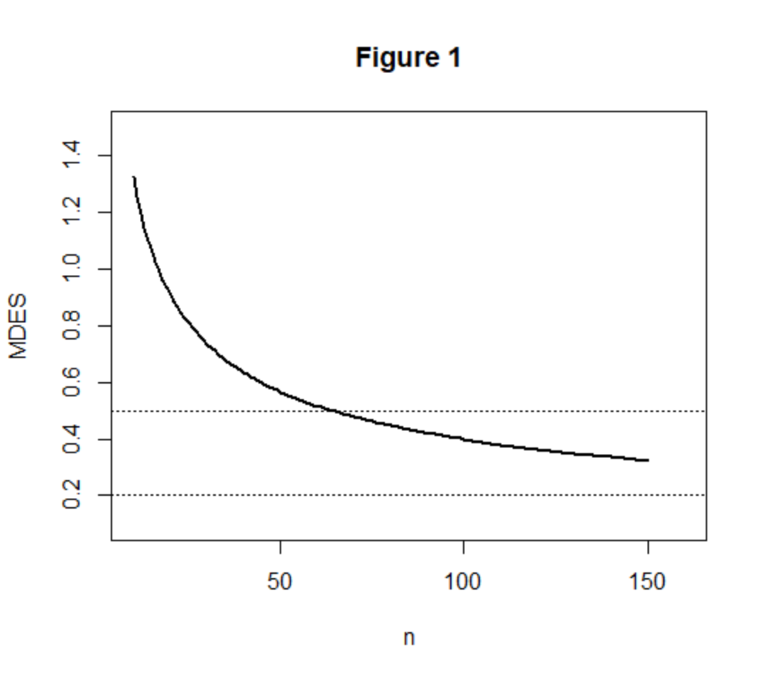

Appendix
Power computations for this design are based on the sampling distribution of the F-statistic given in the text. When there is no block treatment interaction and δ² ≠ 0, then F has the
noncentral F-distribution with n^{T} + n^{C} – 2 degrees of freedom and noncentrality parameter
(see, e.g., Searle, 1971). Therefore, the statistical power of the level α test of the null hypothesis H₀: δ² = 0 is
G[c_{α}| λ, n^{T} + n^{C} – 2]
where c_{α} is the 100(1 – α) percentile of the central F-distribution with n^{T} + n^{C} – 2 degrees of freedom and G[x | λ, ν] is the cumulative distribution function of the noncentral F-distribution with ν degrees of freedom and noncentrality parameter λ.
The approximate minimal detectable effect size can be obtained using a formulas in Bloom (1995) or by iteratively computing power with successively larger values of the effect size until the appropriate power is obtained.

Figure 1
Minimum Detectable effect size as a function of group sample size n



